**Germany – Feedback**

1. Script Format

Type of Regulation – Please use the English equivalents of the regulation types, similar to what was applied in France.

Protokoll (Protocol)  
Regeln (Regulation)   
Verordnung (Ordinance)   
Übereinkommen (Convention)   
Gesetz (Law)

Date – Kindly follow the date format outlined in our feedback for the UK and France.

Note that we apply these format rules for all jurisdictions. Also, kindly include only those legislations that fall under the above-mentioned types of regulations in the output. Other types of regulation such as Vertrag (Treaties) and Rechtsnormen (Legal Norms) should be excluded.

**Germany – Update**

1. Entry into Force Date – As specified in the instruction, this field should be left blank, as the information is not explicitly provided on the legislation site. Based on recent **feedback from the client SME**, however, they instructed us to retrieve this in the alternate site <https://www.recht.bund.de/>

Below is how you navigate the alternate site.

The search functionality is available under the [Recherche](https://www.recht.bund.de/SiteGlobals/Forms/Suche/Expertensuche_Formular.html?nn=55634&federfuehrung.GROUP=1) (Search) section.

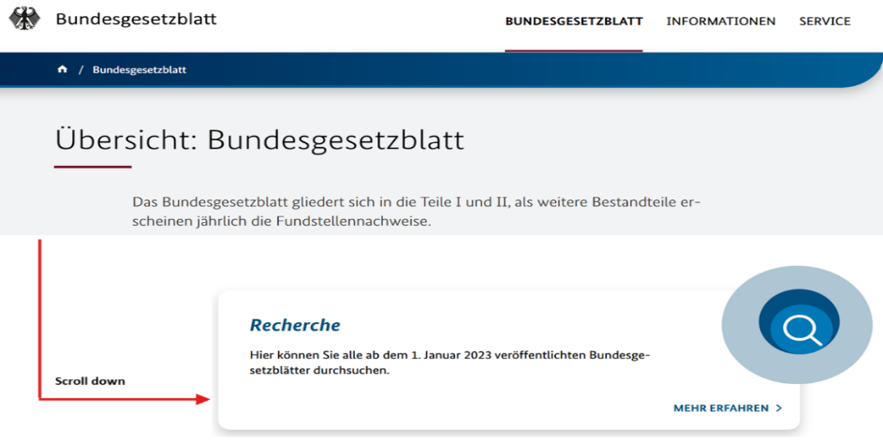

Recherche section has an Advanced Search feature.

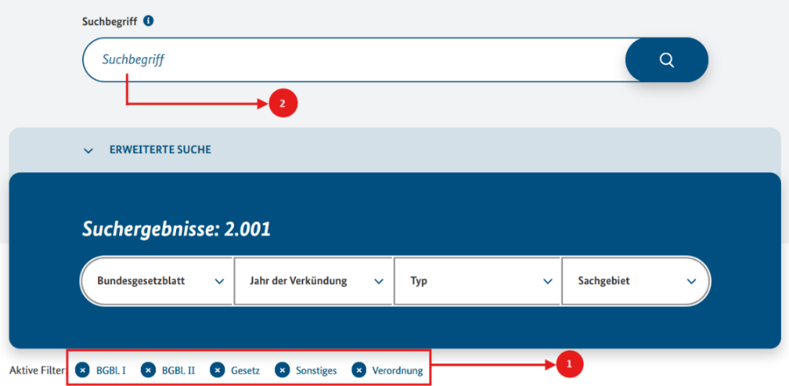

In the [Erweiterte Suche](https://www.recht.bund.de/SiteGlobals/Forms/Suche/Expertensuche_Formular.html?nn=55634&federfuehrung.GROUP=1) (Advanced Search), filter result by selecting the document source BGBl. I (Federal Law Gazette I), BGBl. II (Federal Law Gazette II), Gesetz (Law), Sonstiges (Miscellaneous) and Verordnung (Regulation) as indicated in (1). After selecting the necessary filters, enter the keywords in the full-text search field Suchbegriff (Search term) as indicated in (2).

The search was conducted using keywords from the ESG keyword criteria document. To refine results, we enclosed keywords in quotation marks to force exact matches. Matches on the results page were drawn from both the title and the body/content, as the current search function does not restrict exact keyword matches to the title alone, but it also retrieves matches found within the full text of the document.

On the results page, the full metadata (i.e., original title, source link, type of regulation, date of adoption, and **entry into force date**) is visible. The type of regulation was inferred based on the document context and visible within the title. In the screenshot below, we used the keyword Verschmutzung (Pollution). The keyword does not appear in the title but is found within the body text of the legislation, which is accessible through the PDF document. 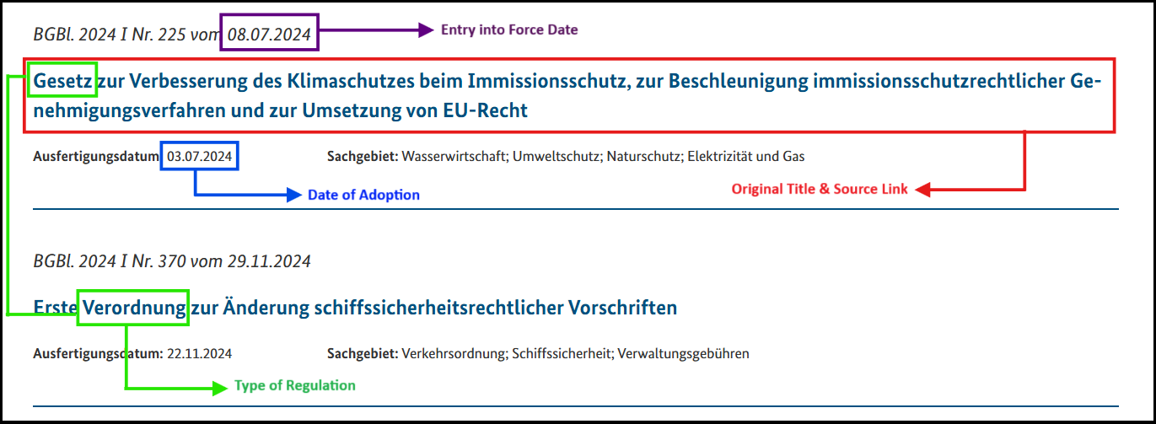

1. Missing Entries

Types of Regulation – Some entries did not include the type of regulation. We initially specified in the instruction that the type of regulation typically appears at the beginning of the legislation title. This may have led to a conclusion that it always appears at the beginning as there are cases where the type of regulation appears in different parts of the title. You can notice these by matching the terms Protokoll (Protocol), Regeln (Regulations), Verordnung (Ordinance), Übereinkommen (Convention), and Gesetz (Law) in the title.

For example, in row 11, the title reads "Internationales Übereinkommen von ..." (International Convention for...), and in this case, the appropriate type to extract is "Übereinkommen" (Convention).

